Experiment No.: 2 Date:
Converting Image to Gary Scale
Aim: Using OpenCV convert the provided image to Gray Scale.
Theory:
Here are some of the important function in OpenCV
Use the function cv2.imread() to read an image. The image should be in the working directory or a full path of image should be given.
Use the function cv2.imshow() to display an image in a window. The window automatically fits to the image size
cv2.imshow('image',img)
First argument is a window name which is a string. second argument is our image. You can create as many windows as you wish, but with different window names
cv2.waitKey() is a keyboard binding function. Its argument is the time in milliseconds. The function waits for specified milliseconds for any keyboard event. If you press any key in that time, the program continues. If 0 is passed, it waits indefinitely for a key stroke. It can also be set to detect specific key strokes like, if key a is pressed etc which we will discuss below.
cv2.destroyAllWindows() simply destroys all the windows we created. If you want to destroy any specific window, use the function cv2.destroyWindow() where you pass the exact window name as the argument.
Changing Color-space - There are more than 150 color-space conversion methods available in OpenCV. But we will look into only two which are most widely used ones, BGR ↔ Gray and BGR ↔ HSV. For color conversion, we use the function cv2.cvtColor(input_image, flag) where flag determines the type of conversion. For BGR→Grayconversion we use the flags cv2.COLOR_BGR2GRAY. Similarly, for BGR → HSV, we use the flag cv2.COLOR_BGR2HSV.
Procedure:
- Login to the Raspberry Pi
- Using the nano editor in the terminal write the following python code
sudo nano 2GrayScaleImage.py
- To run the above code, use the command, and note down the observation
sudo python3 2GrayScaleImage.py

Sample Code- 2GrayScaleImage.py
import cv2
image = cv2.imread("Pictures/image_goa.jpg")
cv2.imshow("Original", image)
cv2.waitKey(0)
gray_image = cv2.cvtColor(image, cv2.COLOR_BGR2GRAY)
cv2.imshow("Grayscale", gray_image)
cv2.waitKey(0)
cv2.destroyAllWindows()
Observation:
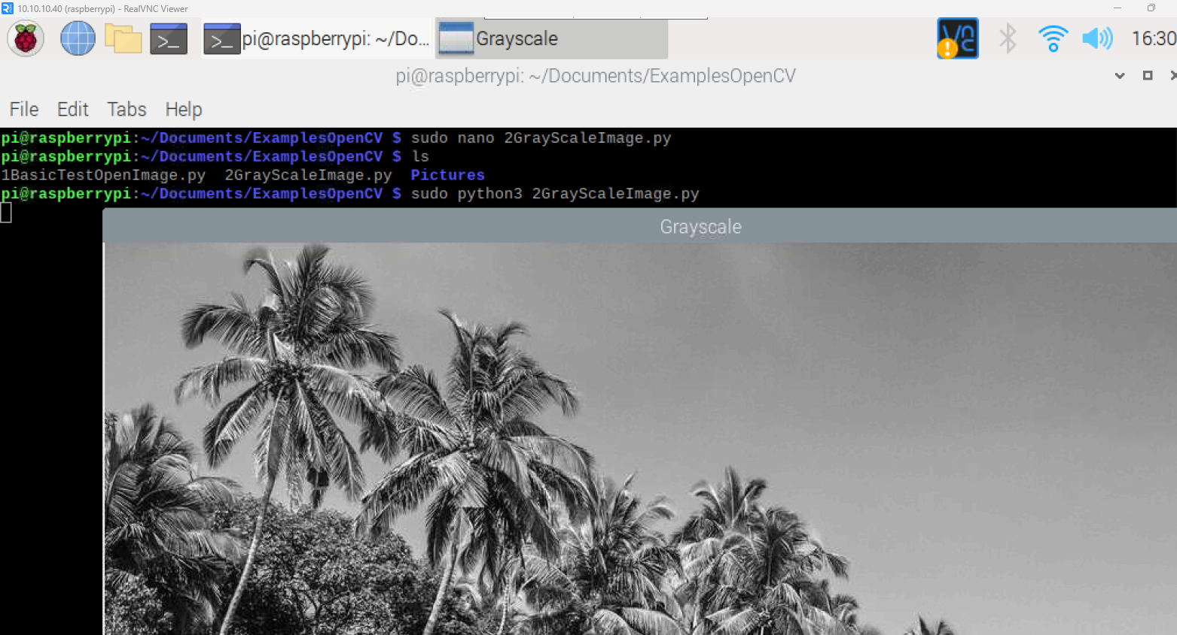
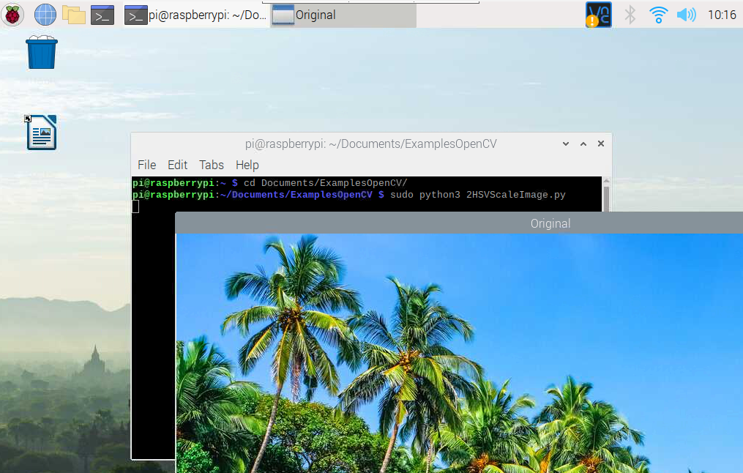

Conclusion: I was able to successfully convert the image into Grayscale and HSV.

